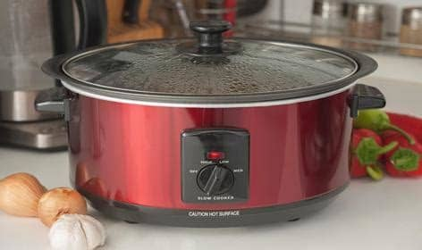

Slow Cookers

**Compared to the standard electric oven, slow cookers use less energy, which allows you to save more money in the long run. It can help you save on costs you would incur in using other appliances to prepare the meal.**

**Most modern slow cookers use as little as 150 Watts an hour if used at the ‘Low’ setting. A six-hour cooking session will use 900 Watts, which is a lot less than an electric stovetop or oven will need for the same amount of time.  If you consider the**[**size of your slow cooker**](https://ovenspot.com/slow-cooker-size-guide/)**, the temperatures you use, the amount of food you cook, and your cooking time, you could cut your electricity cost for cooking in half. A good old ‘crock pot,’ as they are often, referred to utilise the same amount of electricity as your bedroom light bulb. This is much less than an electric oven and cheaper than a gas fired hob.**

**Cheaper food shop**

**So how exactly can a slow cooker boost the amount of cash left in your pocket at the end of the week? Well, have you ever wandered down a supermarket’s reduced to clear aisle and turned your nose up at a chunk of meat that at first you think is a great offer but on closer inspection looks a bit tough? The toughest cuts of meat are ideal for a slow cooker as they are turned into tender cuts as the slow cooker works its magic throughout the day. Flavoursome dishes that can be demolished by your family over dinner whilst you sit back, safe and assured in the knowledge that the lamb/beef or pork was bought at a bargain price but the dish tastes fantastic. It’s been cooked slowly, so delicious meat will literally fall off the bone.**

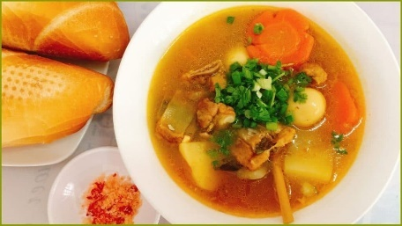**Slow cookers offer many benefits including less electricity usage than traditional ovens, the convenience of not having to check the food’s progress regularly, and a budget-friendly alternative to preparing food in bulk. Slow cookers make it possible to create tasty meals with greater ease.**

**Meals Will Be Healthier**

**Food prepared at high temperatures is not as nutritional as it should be because the heat breaks down the nutrients.  When you’re preparing meals over lower temperatures, as you do with a**[**slow cooker**](https://ovenspot.com/are-slow-cookers-energy-efficient/)**, the food is healthier (and tastier)! Furthermore, no dangerous chemicals are released, which sometimes occurs when cooking at very high temperatures.**

**There are also many delicious and healthy recipes to choose from. Even if you’re on a strict diet or need to change your eating habits for better health, slow cookers will help keep your meals delicious.**

**Another factor that makes**[**slow cookers**](https://ovenspot.com/pea-and-ham-soup/)**an advantage to anyone who wants to eat healthily is that it preserves nutrients.**

Some Useful Recipe Sites to start your SLOW COOKER JOURNEY ……

Give these a go,

BBC FOOD

[www.bbc.co.uk/food/collections/easy_slow_cooker_recipes](http://www.bbc.co.uk/food/collections/easy_slow_cooker_recipes)

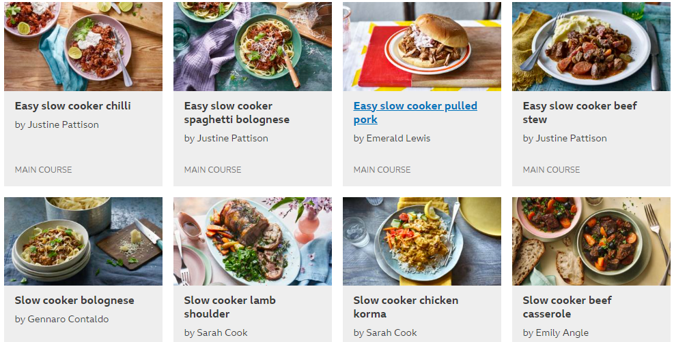

<https://realfood.tesco.com/> www.poppycooks.com/series/slow-cooker

[www.slowcookerclub.com](http://www.slowcookerclub.com) www.slowcookerkitchen.com

[www.themagicalslowcooker.com](http://www.themagicalslowcooker.com) [www.lianaskitchen.co.uk/slow-cooker](http://www.lianaskitchen.co.uk/slow-cooker)

_________________________________________________________________________________

***ARE YOU STRUGGLING AT HOME TO USE THE OVEN/HOB – electric too expensive? Ask us at Brandwood how we can help you. Phone : 0121 443 3310***