Top Ten Energy Saving Tips
Saving energy costs in the home

 | Don't heat your whole home when you spend most of your time in one room. Make sure you control which rooms you heat, so you're not wasting cash heating empty rooms. You can simply go round the house and turn off the radiators in the rooms you don't want to heat. ALSO Keep your doors closed - a simple but effective way of reducing draughts and keeping in the heat
 | 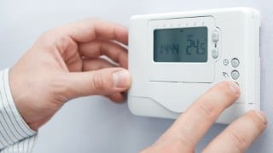  Turning your thermostat down  Just one degree has a much bigger impact than most  people think. 18°C is enough for healthy adults, with  slightly higher temperatures needed for the very old or young.
 | Reduce Condensation and Damp  When you cook, put a lid on pans and keep the kitchen well ventilated. Try to hang your washing outdoors as much as possible during winter. Create a gap between furniture and walls to stop air from getting trapped. Make sure you clear your windows of condensation regularly so it doesn't cause damage or develop into mould- you can do this easily with a towel, tissues. Use extractor fans if you have, if not wipe down bathroom services after use.
 | Batch-cook meals to cut oven use  If you have the time, batch-cooking dinner for the next few days or for the week ahead is the most energy efficient way to cook. You can double or triple portion sizes, or cook multiple different meals at once, freeze anything you don't use, then portion that out over the coming days. Just remember to defrost each portion in the fridge overnight so you're not using the microwave to defrost food.
 | Hot Water Controls  The hot water temperature on your combi boiler is another setting you should check. This controls the temperature of the water that comes out of your hot water taps. By default this temperature is often too high, so a simple change will ensure you're not overspending by heating your water to a higher temperature than you need to. A temperature of about 55°C should be enough for most. Essentially, if you are diluting the hot water with a lot of cold to reach the desired temperature in your bath, it is likely too hot and you're wasting cash.
 | Saving on Water  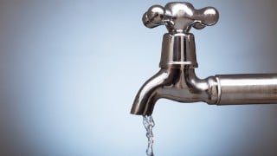  Use a washing-up bowl – rather than leaving the tap running when washing up. Fill a washing-up bowl to do the dishes rather than the whole sink, or just washing dishes under a running hot tap. This way, you'll save on the heating and the water Don’t leave the water running when you brush your teeth or shaving. Swop your bath for a shower.
 | 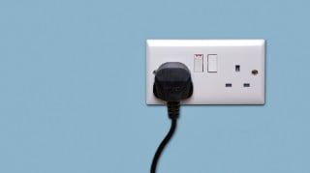  Leaving devices on standby won't use as much as rumoured, but turn them off if you can  While switching off devices instead of leaving them on standby is a good idea – as you're using energy for something you're not making use of – the amount you can save is likely fairly low – but it all adds up!! The Energy Saving Trust says you can save £65 a year by switching devices off standby, while British Gas says it could be £147 a year.
 | Don't assume all energy-saving light bulbs are equal  LED lights use about half the energy of the bigger fluorescent spiral 'energy-saving bulbs' and last for a lot longer too. The Energy Saving Trust says that by switching your 50-watt halogen bulbs to LEDs, you could save up to £6 per bulb per year. As a rule of thumb, you'll want to look for light bulbs with the lowest watts. Obviously turning any lights off when you're not in the room helps too. Some worry that constantly turning lights on and off wastes energy but, according to the Energy Saving Trust, you're better off turning them off when you leave the room, no matter how long for.
 | Put reflective panels behind radiators  Reflective panels behind radiators could help cut energy use. These are sheets of reflective material that you place between the back of the radiator and the wall so heat doesn't escape through the external wall. You could do this yourself with tin foil, though it won't be as effective as actual reflector panels, as foil can crinkle, rip and oxidise more easily, reducing its effectiveness. [If you need these panels installing ask Brandwood to refer to you to the Green Doctor for free]
 | Using Appliances Efficiently  Do one fewer load of washing a week and make sure you fill up the machine each time. You could save by avoiding using the tumble dryer where possible, as it's one of the most energy-hungry appliances there is. According to the Food Standards Agency, you should keep fridges at 5°C and freezers at -18°C. Don't waste energy by having them set colder than this. The more water you boil, the more energy you use. Be conscious about this when filling the kettle, so you don't overfill. Simple, but effective, with a saving of £13 a year possible. If you can use your microwave instead of the oven to cook certain foods, do. They use less energy than ovens because they only heat the food, not the air around it. [See list attached for typical costs].  [Slow Cookers are a great, cheap to run option – DO YOU NEED ONE? Ask JOANNE at the Brandwood Centre]

Brandwood Centre, 157 Allens Croft Road, Kings Heath, B14 6RP

Contact us by phone : 0121 443 3310 Email : joanne@brandwoodcentre.co.uk


Priority customers
The Priority Services Register (PSR) helps gas and electricity companies look after customers who have additional communication, access or safety needs. It’s free and easy to join and gives extra support to those who need it. [ASK JOANNE at BRANDWOOD and we can sign you up to this service.]

